1:number of primr in a specific range:

<https://mettl.com/corporate/analytics/share-report?key=E6H7ma2L6Kdi8kkWP0GusQ%3D%3D>

2:Most Frequent Digit:

<https://mettl.com/corporate/analytics/share-report?key=LlGI8YZw2cwA2cXIoDpi9A%3D%3D>

3.How ManyAreEvenOdd 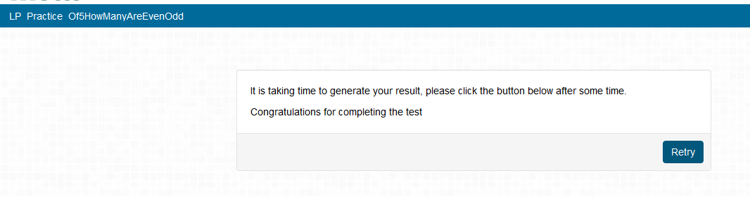

4.IsPrime

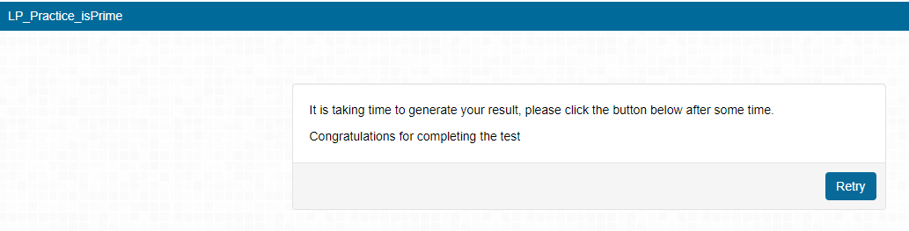

5.Fibonace :

